
Date | 30 September 2026
Team ID | SWTID-2026-1412
Project Name | Import Data using Transform Maps (Spreadsheet)
Team Leader | Hari Jeyalakshmi M
Team Member | Raja Sri M
 | R Pavithra
 | S Muthumari
Maximum Marks | 5 Marks

Project Title:
Import Data using Transform Maps

5. Project Development Phase

During this phase, the planned configurations were built in the ServiceNow Personal Developer Instance (PDI):

- Created the u_employee_test table and configured the form layout to include the necessary string fields.
- Loaded the Sample Spreadsheet.xlsx data, which automatically generated the u_employee_import staging table.
- Created the Transform Map named "Sample Spreadsheet Import" and successfully mapped the fields using the Auto Map feature.
- Executed the transform process, resulting in the successful insertion of initial employee records into the target table.

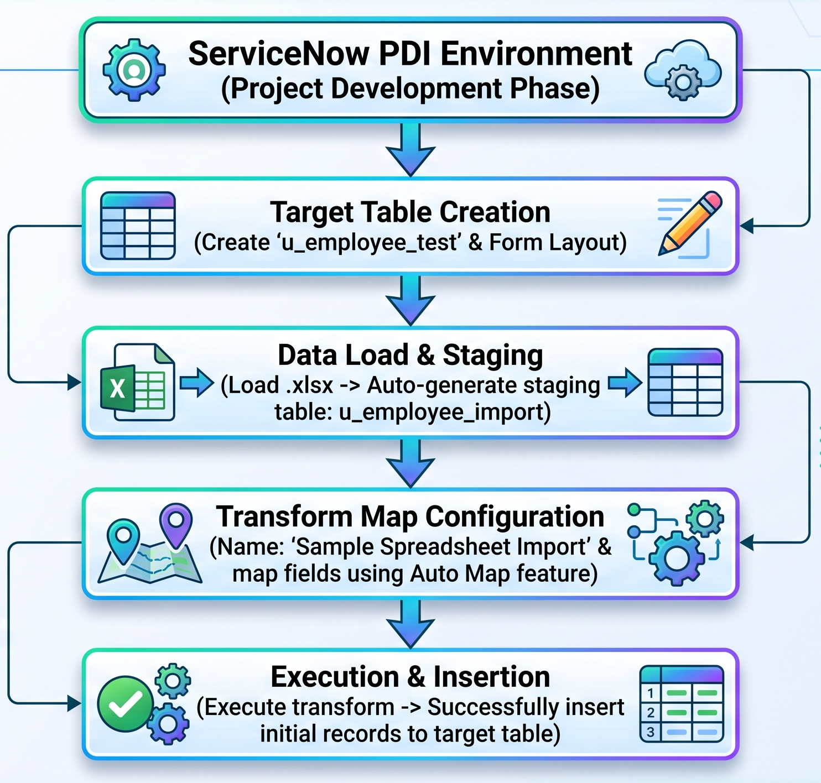

Screenshot:

